CM50266 Applied Data Science

Lab 1: Weather Visualisation

**Task 1**

Min, Max, Mean and Standard Deviation for Each Component

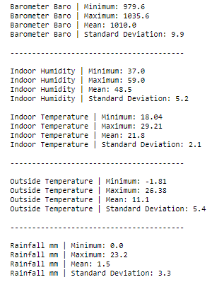

Weather Component Pair Plots

**Task 2**

Mark 2:

Since the results of the 5 weather components are quantitative, I chose to use Position and Length for encoding the data as visual properties. These 3 are ranked at the Top 5 highest properties from Mackinlay’s Retinal Variables. For Humidity, Indoor Temperature, and Outside Temperature graphs I used bar plots, which uses length as its visual mapping having an effective way of helping to distinguish the ordering and ordinal differences of the results. For Barometric Pressure and Rainfall, I have used position as the main visual mapping with the use of Point Plots as it clearly shows the differences in values amongst the months and seasons. Position being the highest ranked variable it is very effective in showing how the rainfall coverage and barometric pressure varies throughout the months and seasons and where the peaks and troughs are.

Mark 4:

For the graphs within the infographic I have chosen different colours and colour properties to help draw attention and encode data. For both the temperature graphs I have used a ‘coolwarm’ Sequential colour palette that shows linear regression of data values. Taking advantage of people’s intuition, I have mapped the temperatures with the lower values to blue to indicate cold, diverging to the higher values that are shown in orange to indicate hot. For the Humidity graph I have chosen to use the colour blue with varying Saturation, since darker regions indicate higher values this application of brightness scale aligns with people's intuition. Finally, I have coloured the area under the line plot in the Rainfall graph with blue to show the varying water level measurements amongst the months and seasons. For the infographic I have used muted colours such as orange and blue that are both fitting to the theme and data but are also relaxing and pleasing to view.